DC 44
ELECTRICAL DIALYSIS AND CHEMOTHERAPY CHAIR, 4 MOTORS
- 4 motors for electronic adjustments of backrest, legrest, height, and Trendelenburg functions by hand control unit
- Suitable for Hemodialysis and Chemotherapy sessions
- Anti-microbial, water proof, flame retardant, air permeable and easy cleanable cushion and not effected to skin
- The chair is upholstered by viscoelastic foam which is known as memory foam, is a type of open cell, flexible polyurethane foam. It is body heat and weight sensitive material. It contours to the body shape, distributes the body pressure over a wide area and besides comfortable seating, allows for good blood circulation
- Foam’s capacity let the patient redistribute weight and surface pressure, potentially reducing decubitus ulcers
- ABS covering designed to keep itself in the upholstery and it blocks the dust which goes into the upholstery
- During the back rest movement, arm rests moves with the back rest simultaneously and the arm rests are easy removable
- Easy adjustable and removable upholstered arm rests
- Adjustable and removable cramp support and head support
- Head support provided with cushion for neck support
- 360° swivel, diagonal lockable castors of 125 mm diameter
- Height adjustable IV pole with 2 hooks
- Food / Reading Table (optional)
- Rechargeable Back-up battery (optional)
- Weighing Scale (optional)
- Central brake castors, 125 mm (optional)
- Manual CPR (optional)
- Tablet with holder (optional)
- Reading lamp (optional)
 | TECHNICAL DETAILS
 | Backrest Angle | : 0°-70°
 | Trendelenburg Angle | : 0°-13°
 | Reverse Trendelenburg Angle | : 0°-(-5)°
 | Legrest Angle | : 0°-35°
 | Safe Working Load Capacity | : 180 kg
 | Weight | : 115 kg
 | External Dimensions (with Armrest) | : 201 x 105 cm
 | Bed Surface | : 201 x 65 cm
 | Height Range | : 55-75 cm
 | Castor Diameter | : 125 mm

 | ELECTRICAL DATA
 | Power In | : Max. 3,15A 100V-240V ~ 50-60 Hz
 | Electrical Shock Protection | : Class I, Type B
 | Liquid Ingress Protection | : IP66

ACCESSORIES
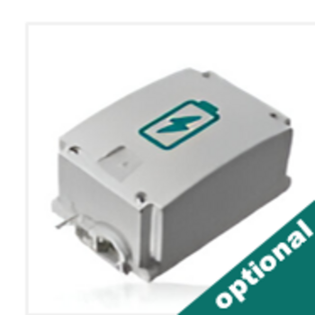
Rechargeable Battery Backup
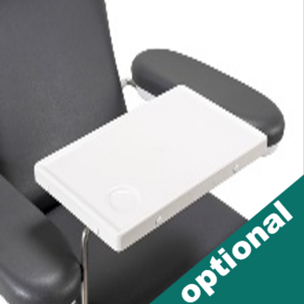
ABS Food/Reading Table
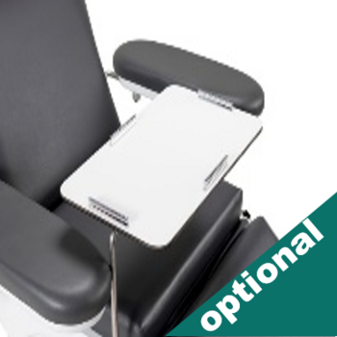
HPL Food/Reading Table
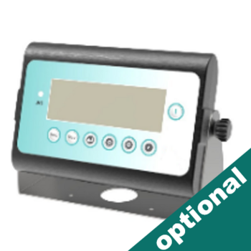
Weighing Scale
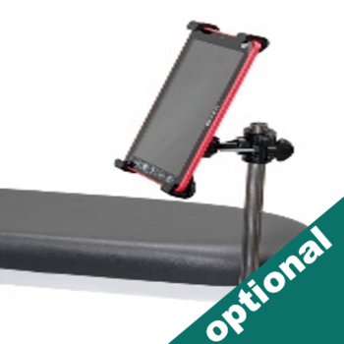
Tablet with Holder
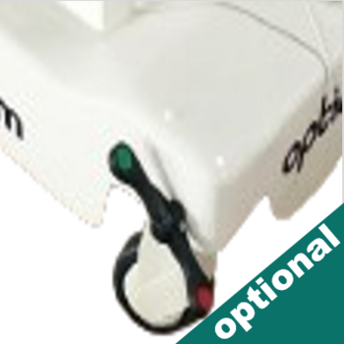
Central Brake Castors 125 mm
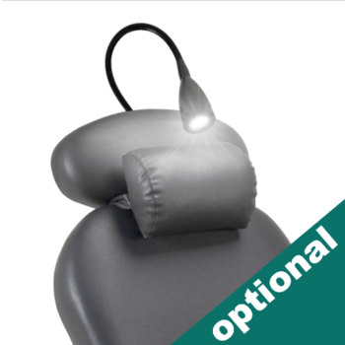
Reading Lamp
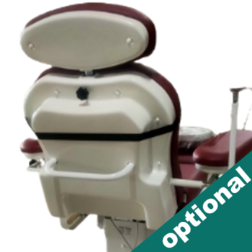
Pushing Handle
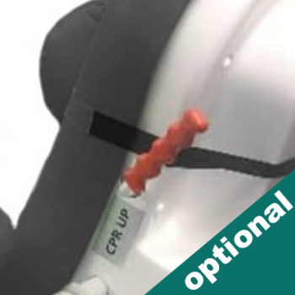
Manual CPR
COLOR CHART
